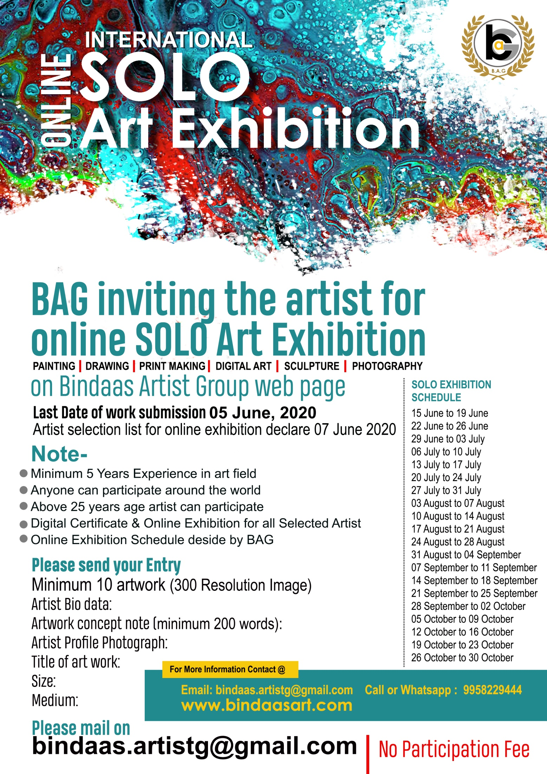
International Online
SOLO ART EXHIBITION 2020
Entry close from: 05th June 2020
Online Exhibition from 15 June to 30 October 2020
About BAG
One of the main goal of BINDAAS ARTIST GROUP is to reveal the socio cultural similarities Among the people speaking different language, to explore, to protect, to develop and maintain the common civil heritage.
The multi dimensional activities of Bindaas Artist Group are not only limited to cultural relation And cooperation between the member states but also it aims at strengthening the ties of friendship Peace, tolerance and solidarity in all over the world without intervening the administrations. Sovereignties or domestic and foreign policies of the member states.
These gathering have brought us in nearly a thousand of art works created by more than 150 artists Fron different countries.
We believe in importance of sharing cultural experiences. For this reason, BINDAAS ARTIST GROUP is presenting the very special works from all over world painting collection with this exhibition. We hope this exhibition would help different cultures to get closer and bring us universal dimensions for our artistic and cultural treasures. In this context, I would like to thank all of the artists for bringing us these magnificent works of art and I wish them success in their future works. ADMIN BINDAAS ARTIST GROUP.

Foundation
Bindaas Artist Group for Indian Art is dedicated to fostering exploration, understanding, and enjoyment of the visual arts of the India for national and international audiences. Recognizing the importance of experiencing original works of art, the foundation provides opportunities for interaction and show case of work, beginning with the presentation and growth of its own art collection in India. To further cross-cultural dialogue on India art, the foundation supports and collaborates on innovative online Art exhibitions, Art competition, and promotion programs. Implicit in such activities is the belief that art has the potential both to distinguish cultures and to unite them.

Why submit your art works?
Opportunity to online art exhibit a prestigious Online Group, alongside well-established artists
Have your work seen by thousands of visitors
Chance to sell your work to buyers and collectors
Opportunity to special attention to the visitor

NOTE:
- Minimum 5 Years Experience in art field
- Anyone can participate around the world
- Above 25 years age artist can participate
- Digital Certificate & Online Exhibition for all Selected Artist
- Online Exhibition Schedule decide by BAG
- NO Registration Fee
Participation Categories:
PAINTING I DRAWING I PRINTMAKING I DIGITAL ART I SCULPTURE I PHOTOGRAPHY
Deadline:
Artist selection list out on 7th June 2020
Online Exhibition From: 15th June to 30th October 2020
Please send your Entry
- Minimum 10 artwork (300 Resolution Image)
- Artist Bio data:
- Artwork concept note (minimum 200 words):
- Artist Profile Photograph:
- Title of art work:
- Size:
- Medium:
​
Please mail on
bindaas.artistg@gmail.com

Registration Form

Artist Name |  |  |  |  |  | Artist Photograph
Father’s Name/ Husband Name
Date of Birth DD/MM/YYYY
Birth Place
Email Address
Contact Nomber
Qualification
Address
SN | Title of works |  | Medium | Size | Month & year of execution |  | Price
1
2
3
4
5
6
7
8
9
10

Declaration by the artist

I hereby declare that I am the producer of these art works and its origional by nature. If anyone complain for copy, or exhibition display any other place then BAG have right to cancelation my entry and block my eligibility for future participation in BAG competition for lifetime.

Signature of the Artist
Place…………………………………………………………….
Date……………………………………………………………..

