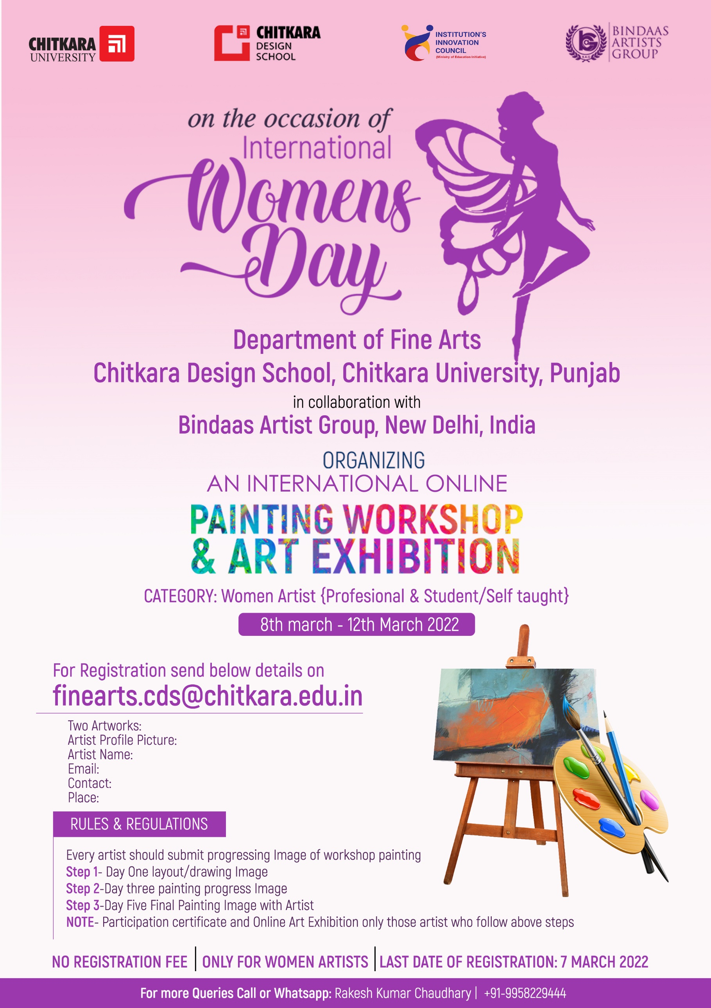

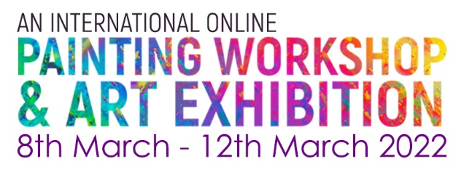
REGISTRATION FORM

Artist Name
Category | Artist Professional | Student/Self-taught
Email
Contact No.
Place/ Country
Painting 1-
Title | Medium | Size | Year
Painting 2-
Title | Title | Title | Title

- Two Artworks Image
- Artist profile picture
- Artist Biodata
- Complete filled form
Send Above details on - finearts.cds@chitkara.edu.in
RULES & REGULATIONS
Last Date of Registration & Artwork submission: 7th March 2022

ONLINE WORKSHOP SCHEDULE
- Day One- 8th March 2022 – (layout/drawing Image)
- Day Two- 9th March 2022
- Day Three- 10th March 2022- (painting colouring progress Image)
- Day Four- 11th March 2022
- Day Five- 12th March 2022- (Final Painting Image with Artist)

NOTE-
- Participation certificate and Online Art Exhibition only those artists who follow above steps
- Photographs of Painting must be in good quality and Clear
- Take painting photographs with artist
Online Exhibition From 3rd April 2022 to 27th April 2022

For more Queries Call or WhatsApp: Rakesh Kumar Chaudhary | +91-9958229444

